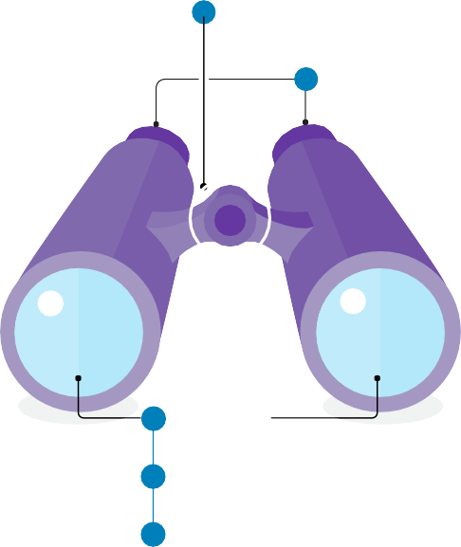
Video Analysis Framework
for Learners and Educators
The Video Analysis Framework (VAF, Packard, Brennan, Joseph, Emerson-Hoss, 2021) involves a series of skills that help educators learn to notice, reflect, analyze, and decide how to act to best support children’s learning and development. To better understand the VAF process, imagine you are looking through a pair of binoculars. Each skill is related to a specific characteristic or function, as described:
Focus -To see clearly you must first focus on something
specific, like how the focus wheel on a pair of binoculars zeros in on one thing while blurring everything else in the background. In busy classroom environments, it is important to select a teaching strategy, course concept, and/or professional development goal that you will pay close attention to for your analysis.
Video Analysis Framework
1 Focus
2
Observe
Observe - The next skill is observation, which can be thought of as looking through the binocular eyepieces which magnify an object. When doing a focused observation, you are working to magnify a certain practice or behavior. Descriptive, specific, and behavioral observations of videos of teaching practices is the intended outcome for this skill.
3
Identify bias
Identify Bias - Identify bias is next, and it is positioned on the binocular’s outer lenses that capture the light.
This helps us understand how everything we see is filtered through our own lens on the world. Everyone’s perspectives and behaviors are shaped by systemic oppression, implicit, and explicit biases. Before moving
4
Interpret
5
Plan to improve practice and disrupt bias
on to the interpret and plan skills, it is important to examine how our personal beliefs, histories, and experiences influence our observations and how we may interpret them. This way we can ensure our interpretations are as free of bias as possible, so we are not wrongly assuming something about the children or the interactions. Advancing equity requires a dedication to ongoing self-reflection.
Interpret – Interpretation uses your observations as evidence for responsive, child-centered teaching decisions. When making interpretations, we take a strengths-based approach and offer ideas for alternative practices. What did the educator do (related to the focus) that worked well? What might they do differently next time to increase the positive impact on children’s learning and development?
Plan to Disrupt Bias and Improve Practice – The last skill is planning to disrupt bias and improve practice. At this stage, educators use their observations, identified biases, and interpretations to make a concrete plan related to the focus of their analysis. In other words, what specific things will the educator do in the future to enhance children’s development and learning and disrupt bias?
Packard, M. Brennan, C. Joseph, G., Emerson-Hoss, K. (2021). The power of video analysis: Developing professional vision and anti- bias practices for pre- and in-service teachers. Young Children, 77(1) https://www.naeyc.org/resources/pubs/yc/spring2022
Handout: Video Analysis Framework for Learners and Educators
1

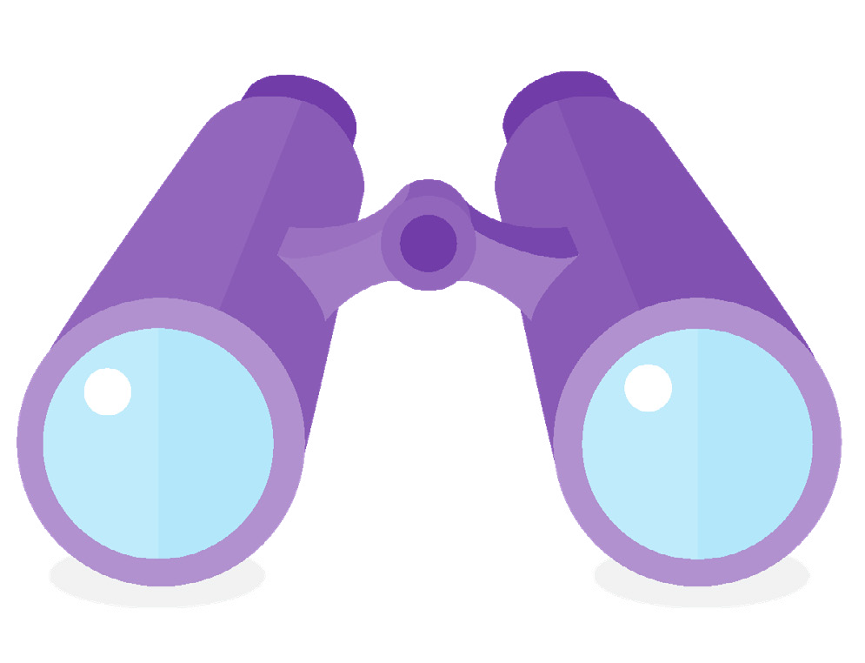
Video Analysis Framework Skills
The Video Analysis Framework is a structured process, grounded in specific observations, that allows educators to improve their practice and enhance children’s learning and development.
Focus: What area of educator knowledge will you focus on? You could draw from course content areas, cultural practices, and/or professional development goals. Example focus: Open-ended questioning and contingent responses.
1
Observe: What objective, specific, and behavioral actions and interactions between educators and children do you notice related to the focus?
2
Identify Bias: Reflect on the following regarding your own biases:
3
a.
How do my culture, personal beliefs, values, and biases relate to structural inequities and their impact on children and families over time? What specific aspects of my background may impact my assumptions about children and
families as I build relationships?
When I become aware of a biased action, am I willing to take responsibility, use the opportunity to learn and reflect, resist becoming defensive, and repair the harm?
What other questions do you have?
b.
c.
d.
Reflect on the following regarding potential biases of the educator in the video:
e.
What do you wonder about the educator’s potential bias?
What questions would you want them to ask themselves?
How might they discover any biases they might have?
f.
g.
Interpret: Based on your observations and identified biases, what are your interpretations related to your focus? Take note of specific, successful moments when the educator supported children. Also, propose one or more alternative practices that the educator could have enacted to enhance children’s learning and development.
4
Plan to Disrupt Bias and Improve Practice: What specific things could the educator do to improve their teaching in the future and disrupt bias?
How does the plan connect to the observations, identified biases, and interpretations?
5
Handout: Video Analysis Framework for Learners and Educators
2

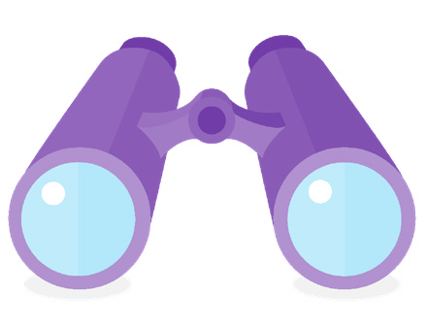
Visual Analysis Framework Worksheet
Use this worksheet to help structure groups or individuals working to improve their practice through video analysis. Using guided practice to begin and moving to independent practice and analysis of one’s own and peers’ videos is a powerful learning tool.
Name(s):
Resources used (include source for content focus and practices in action):
Focus:
Observation:
Identify bias (include what questions you ask yourself or where you wonder bias may show up):
Interpret (explicitly connect observation to content focus and any potential bias):
Plan to disrupt bias and improve practice:
Handout: Video Analysis Framework for Learners and Educators
3

Writing Formative Feedback on Teaching Practice Worksheet
Focus:
Write a formative feedback response that includes the following components. Consider that the educator will respond to your comment in a follow-up reflection or conversation and, based on your feedback, will plan for improvement in a subsequent video of teaching practice.
1. Start with an Encouraging Strength
Describe at least one specific, time-stamped observation of an interaction between the educator and a child that was a successful moment related to the focus. Interpret the observation, explaining why it was successful based on lesson content.
2. Offer an Alternative Idea and Wonder
Wonder about and describe at least one specific alternative idea related to the lesson focus that the educator could have enacted at a time-stamped moment to have better supported a child. Why might this have had a more positive impact on that child’s learning based on lesson content?
3. Support Educator Goals
If the educator shared a written goal related to their ongoing growth along with the video, encourage them to continue reflecting and improving.
4. End with an Encouraging Strength
Wrap up by summarizing one or more of the educator’s strengths, supported by one specific time-stamped observation of an interaction between the educator and a child that was a successful moment related to the focus.
Handout: Video Analysis Framework for Learners and Educators
4

I wonder...



This document was developed with funds from Grant #90YT000037-03-00 for the U.S. Department of Health and Human Services, Administration for Children and Families, Office of Head Start, and (insert something about tribal college project?). It was developed in collaboration between Fond du Lac Tribal and Community College and EarlyEdU Alliance. This resource may be duplicated for noncommercial uses without permission. (c) 2023 EarlyEdU Alliance.
Handout: Video Analysis Framework for Learners and Educators
5
Notes

