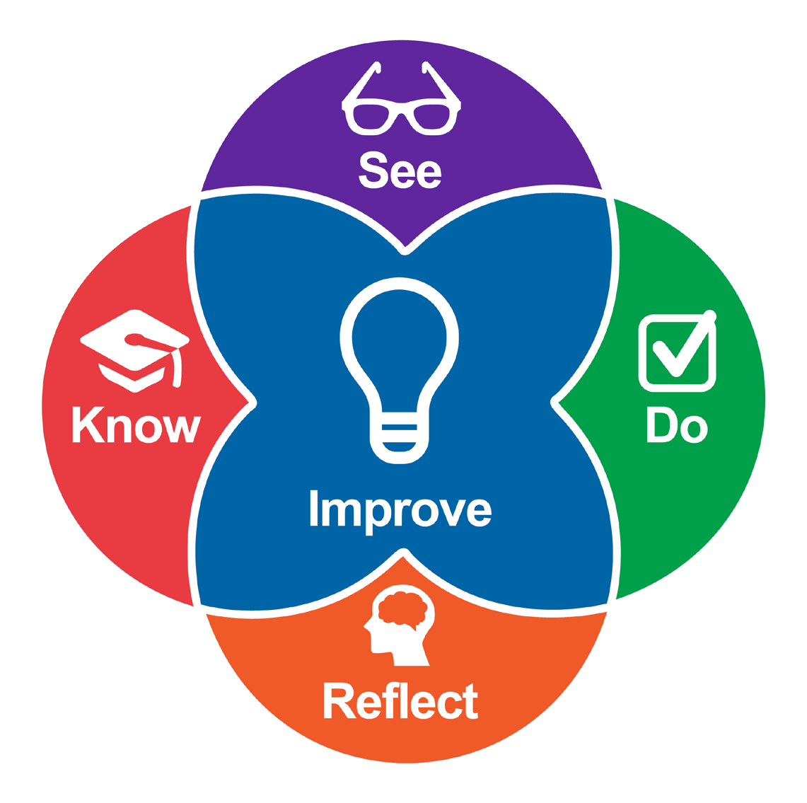
Intentional Teaching Framework
for Students and Teachers
The Intentional Teaching Framework (ITF) is a conceptual framework that uses the authentic practice of working directly with children as an inroad to developing the knowledge and dispositions of effective teaching while honing effective teaching skills. The most effective and sustained learning occurs within practice when you are guided to integrate theory, cultural practices, and knowledge of skills into direct interactions that promote children’s learning and well-being. The five elements described below overlap with one another and provide an iterative cycle for structuring your own learning and development.
Know
Learn about current information on child development, cultural knowledge and practices, and how to interact with children in ways that promote social, emotional, behavioral, and cognitive development.
See
Learn to identify effective educator-child interactions in others as well as in your own interactions.
Do
Practice working with children and engaging in effective educator-child interactions, including role playing during a workshop, courses, planning lessons during a staff meeting, and implementing the practices directly during daily activities.
Reflect
Observe and critically analyze your own
teaching to become more effective. This can happen with self-analysis, one-on-one conversations with a peer, coach, or supervisor, and group discussions.
Hamre, B. K., Downer, J. T., Jamil, F. M., & Pianta, R. C. (2012). Enhancing teachers’ intentional use of effective interactions with children. In R. C. Pianta (Ed.), Handbook of early childhood education (pp. 507–532). New York: The Guilford Press. Joseph, G. E., & Brennan, C. (2013). Framing quality: Annotated video-based portfolios of classroom practice by preservice teachers. Early Childhood Education Journal, 41(6), 423–430.
Handout: Intentional Teaching Framework for Students and Teachers
1


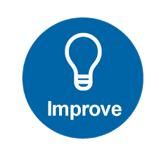


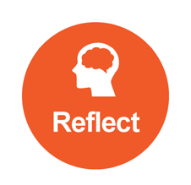
Improve (Pre-cycle)
What are the competencies that you want to be able to demonstrate? What do you want to do better or differently?
□
□
□
□
□
Specific, descriptive, and focused
Linked to child outcomes, cultural practices, state, national, tribal standards Communicated clearly and upfront to yourself, instructor, and/or peers Focused on your improvement over time through feedback and support Able to be measured by evidence of practice
Know
What do you need or what to know about in relation to the focus practice?
□
□
□
□
□
Readings include article, tip sheets Interviews with experts, mentors Presentations and videos
Quizzes
Brief interactive opportunities (motivation to complete)
See
What opportunities do you want to have to help you become reliable observers?
□
□
□
□
Models (live and/or video)
Opportunities to collect and analyze videos
Opportunities to reflect with others on what they see and what they might do
Interactive quiz and video tagging
Do
How can you practice?
□
□
Case Studies/Role play
Activities that build toward application in the field (what you need to do before you apply to practice) Practice in the field and collect video
□
Reflect
What opportunities and questions can guide you toward improvement?
Reflect Examples: What don’t we know? Who am I interacting with and how? Are there differences? What worked/ Suggestions? What was going on for the child? You? The teacher? What is the impact of the teacher-child interactions?
□ Self-reflection
□ Group (constructive peer feedback)
□ Instructor feedback
Improve (Post-cycle)
What are the competencies that you wanted to be able to demonstrate?
□
□
□
□
□
Specific, descriptive, and focused
Linked to child outcomes, cultural practices, state, national, tribal standards Communicated clearly and upfront to yourself, instructor, and/or peers Focused on your improvement over time through feedback and support Able to be measured by evidence of practice
Handout: Intentional Teaching Framework for Students and Teachers
2

Improve (Pre-cycle)
What practice is your focus?
Know
What do you need or want to know? What do you want to find out more about?
See
How will you see this practice in action? What opportunities are there? How will you analyze what you see?
Do
What will you do to practice this skill?
Reflect
How and with whom will you reflect?
Improve (Post-cycle)
How do you know you’ve changed or been successful? What next?
Handout: Intentional Teaching Framework for Students and Teachers
3








This document was developed with funds from Grant #90YT000037-03-00 for the U.S. Department of Health and Human Services, Administration for Children and Families, Office of Head Start, Tribal Colleges and Universities Head Start Partnership Program. It was developed in collaboration between Fond du Lac Tribal and Community College and EarlyEdU Alliance. This resource may be duplicated for noncommercial uses without permission. (c) 2023 EarlyEdU Alliance.
Handout: Intentional Teaching Framework for Students and Teachers
4
Notes

